|  |  |
| --- | --- |
|  | **Computer Organization & Assembly Language**  **BSCS-3**  **Department of Computer Science**  **Bahria University, Lahore Campus** |

**Assignment: [3]**

Date: Week 11, 20th May 2023

Name: _AFFAN AHMAD____________________

Roll No: _03-134221-003__________________

|  |  |  |  |
| --- | --- | --- | --- |
| **Evaluation of CLO** | **Question Number** | **Marks** | **Obtained Marks** |
| **CLO3:** | 1 | 10 |  |
|  |  |  |
|  |  |  |
|  |  |  |
| **Total Marks** | | **10** |  |

**Question 1: [Marks: 10]**

**Project Proposal**

**Must follow these guide line**

* **Previous work**
* **New work**
* **Benefit of your project**
* **Use case diagram**
* **Conclusion**

**Proposal should not be more than 3 pages and not less than 2 pages.**

**Note: If someone want to do work with hardware implementation they can do it.**

**PROJECT PROPOSAL**

**ON**

**“Library Management System ”**

**Course name:** **Computer Organization & Assembly Language**

**Submitted to**

**Maryam Munawar,**

Lecturer,

Department of

Computer science,

Bahria University of Lahore

**Solo project**

**INTRODUCTIUON :**

The project Titled “**library management system “** is a library management software for monitoring and controlling the transactions in a library.

The project **“library management system ”** is developed in assembly language, which mainly focuses on basic operation like adding new member, new books and update new information, searching books and members to borrow and return books.

The software library management system has **four main module**

1. Insertion to database module – user friendly input screen
2. Extraction from database module –attractive output screen
3. Report generation module – borrowed book list and available book list
4. Search facility members – search for books and members

**PROPOSED SYSTEM**

Proposed system is an automated library management system. through software user can add members, add books, update information, edit information, borrow and return books in quick time. proposed system has the following advantages.

* User friendly interface.
* Fast access to database
* Less error
* More storage capacity
* Search facility
* Look and feel environment
* Quick transaction

All the manual difficulties in managing the library have been rectified by implementing computerization.

**LITERATURE REVIEW/Benefits**

A review of literature reveals that a computerized library management system will:

* Help to improve the library services.
* Help the Liberians with management information.
* Help the librarian in reporting on the various operation of the library
* Increase the rate at which tasks are completed accurately.

**CASE DIAGRAM**

Here there is one actor which is librarian, 6 main use cases , (under the line there are some extension point and some extend use cases in this system ).

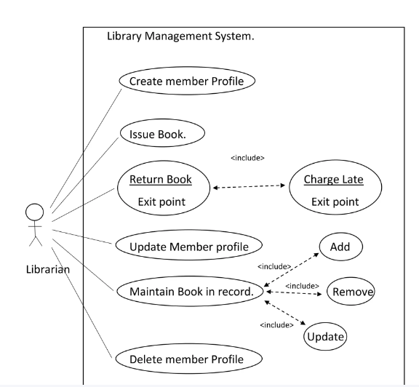

**CONCLUSION**

The library management system needs to be computerized to reduce human errors and to increase the efficiency. The proposed library management system in this proposal will be a computerized management system developed to maintain all the daily work of library. Library management system are designed to store all the information about books and members

The main focus in this project is to lessen human effort and encourage efficient record keeping.